ISLAMIC UNIVERSITY OF TECHNOLOGY

Organization of Islamic Cooperation

Board Bazar, Gazipur

Tracker-Ball Mice

and

CMOS Sensors

CSE 4145

Professor Dr. Kamrul Hasan

**1. Explain the mechanism of how old mice detected forward and backward movement.**

Older mice used a ball to determine the direction of motion of the mouse. This ball would physically touch the user’s desk. There were two rollers inside the mouse that touched the ball. One would be oriented to detect motion in the -direction, and the other oriented to detect motion in the -direction. When the mouse (and thus the ball) was moved, one of these rollers moved as well.

The rollers were connected to a shaft that spun a disk with holes in it. If the rollers rotated, so did the shaft and disk. On either side of the disk, there were LED lights and infrared sensors. The holes in the disk would break the beams of light coming from the LED (as shown below) so that the infrared sensors saw pulses of light. The rate of pulsing was directly related to the speed and direction of movement of the mouse. An on-board processing chip read the pulses from the infrared sensors and turned them into binary data that the computer would understand and move the cursor accordingly.

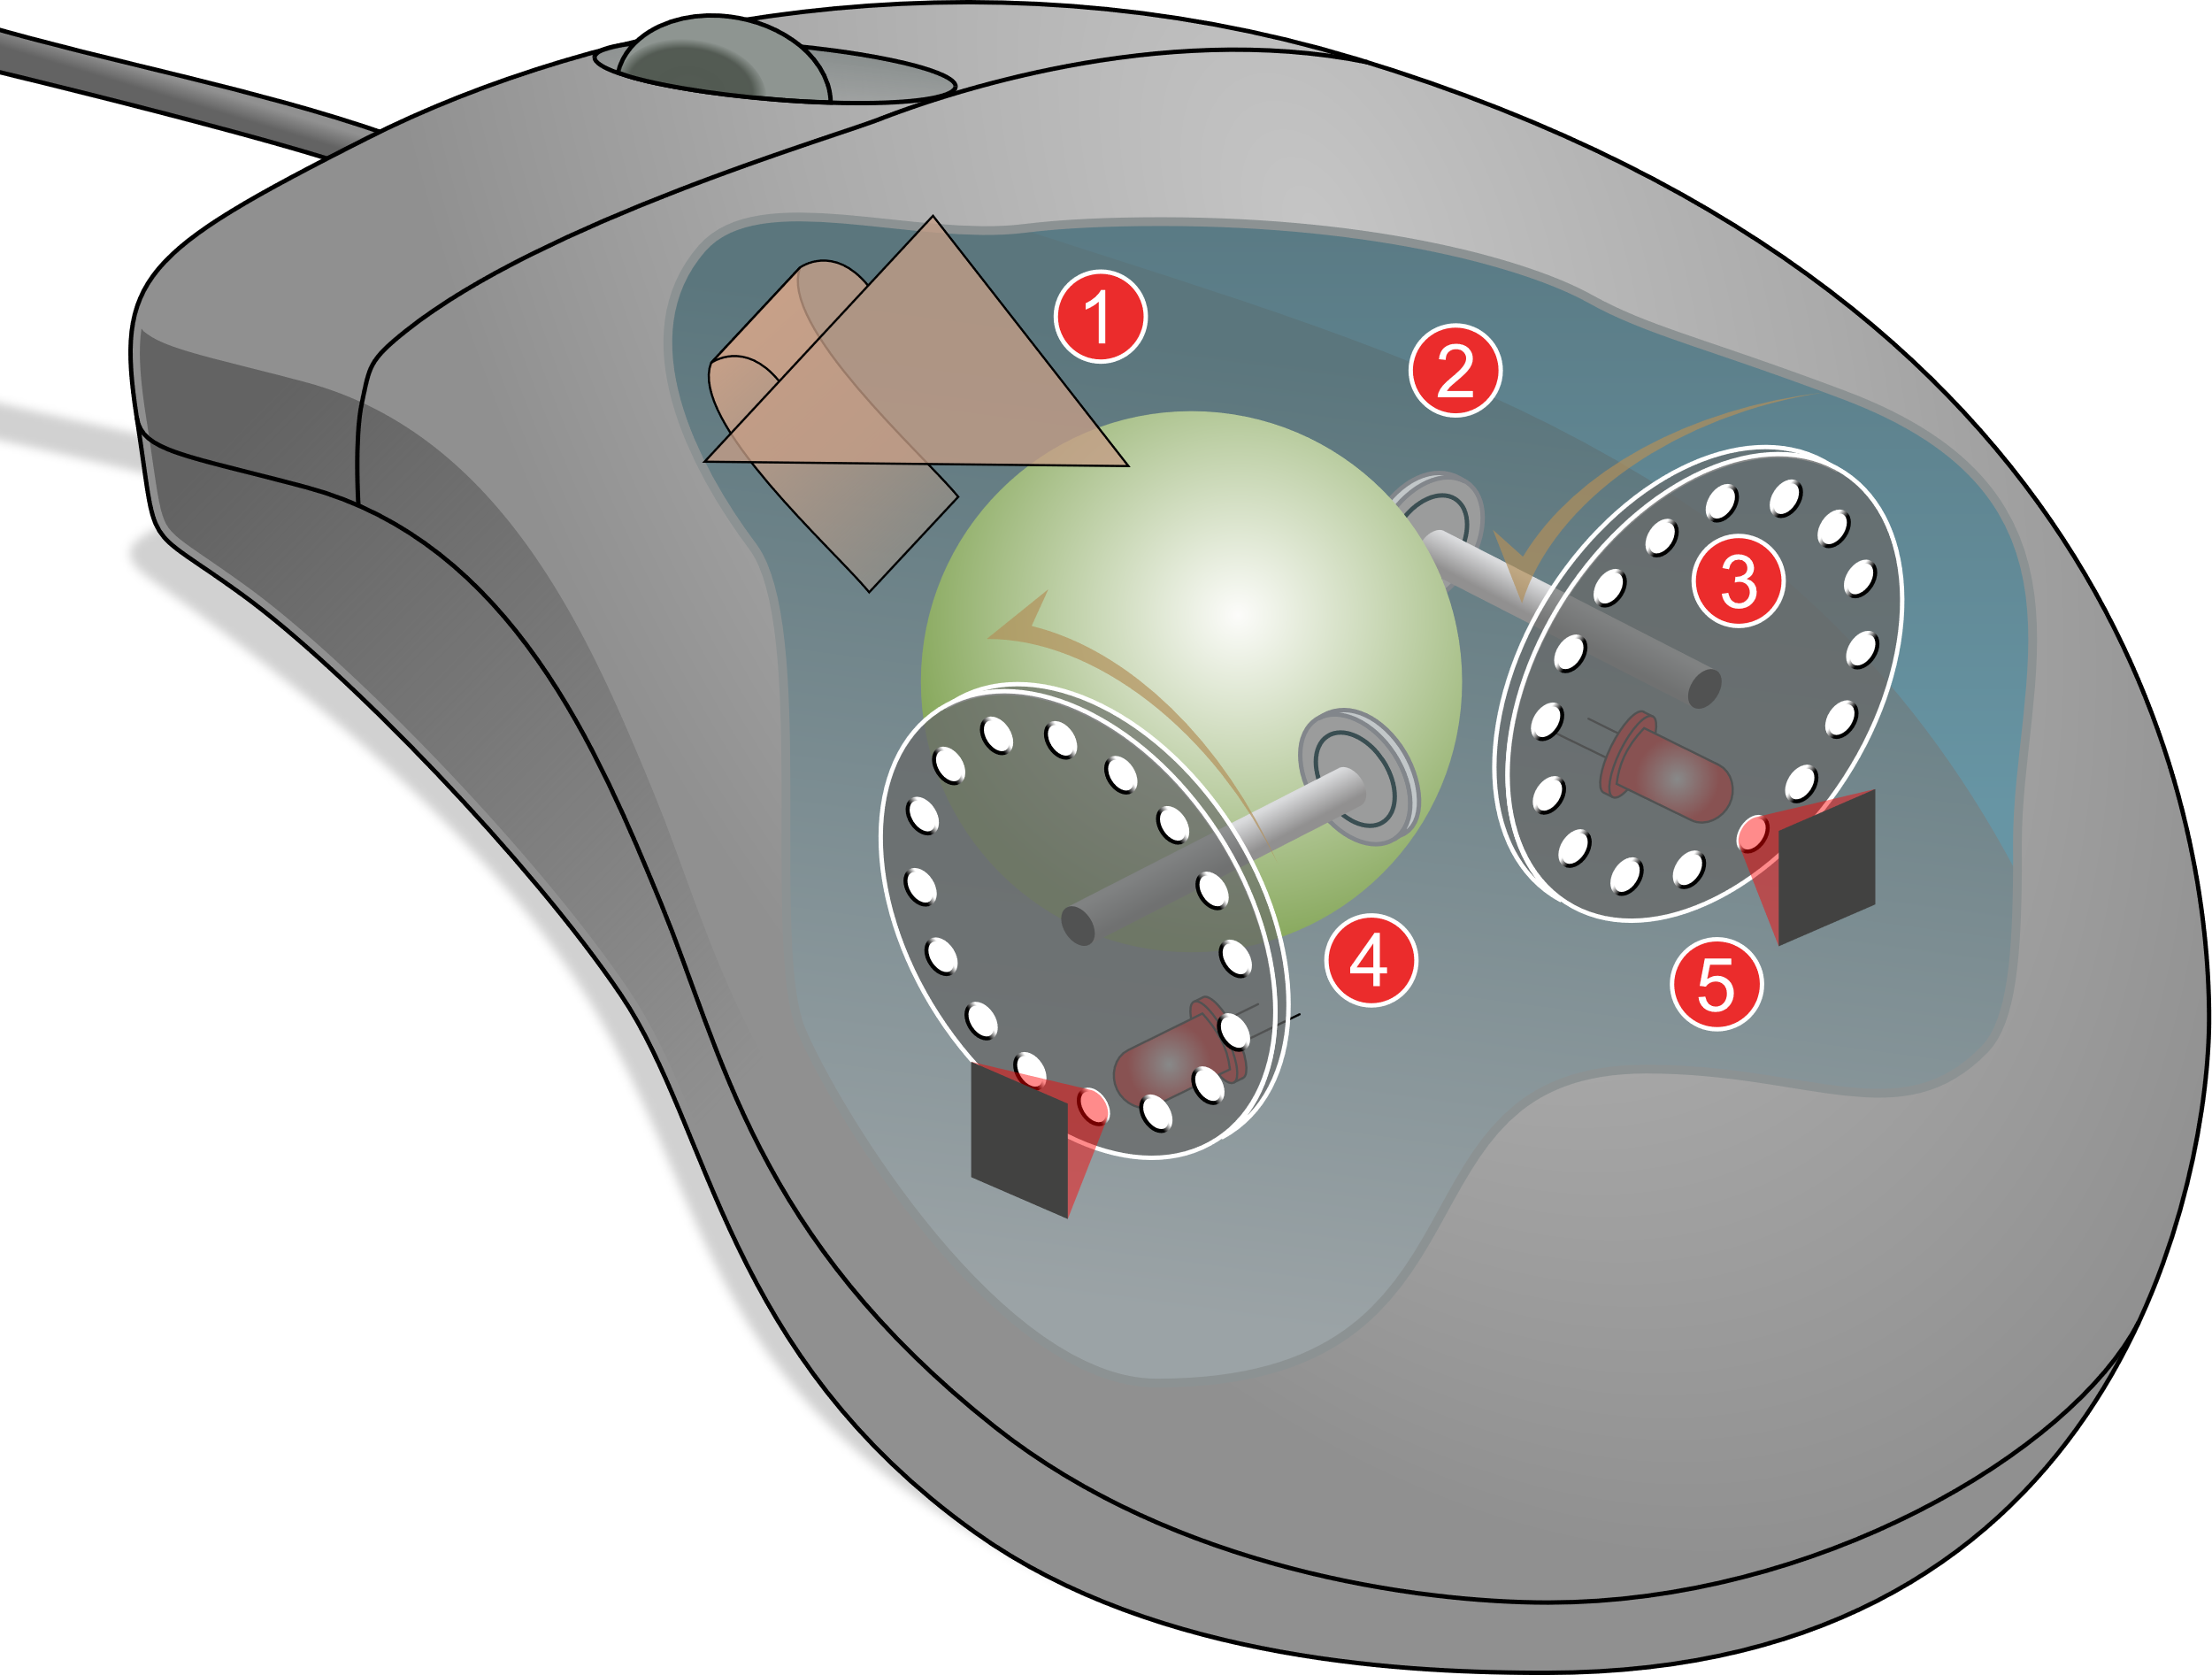

**2. How do CMOS sensors work in optical mice?**

Optical mice are mice that use LEDs to track movement. This is achieved when the light from the LEDs reflects off of a surface and onto the CMOS sensor.

A CMOS (Computed Metal Oxide Semiconductor) Sensor is an electric chip that converts photons to electrons for digital processing. The mouse uses a tiny camera with a high frame rate to detect light from the LED. This is sent to the CMOS Sensor, which converts it to an electrical signal and sends it to the DSP (Digital Signal Processor) for analysis. The DSP operates with several million instructions per second, so it is able to detect patterns in the images and detect changes in those patterns due to movement. Depending on how the pattern changes over several consecutive images, the DSP is able to determine how far the mouse has moved and in which direction. It sends this information to the computer which moves the cursor on the screen accordingly. Since this happens hundreds of times every second, the cursor appears to move smoothly.